1. Test Plan Identifier
File Name: 1.O_KSRTC_tplan_v1.0.doc
Location: Hyderabad
2. Document History
REV | Author | Edits | Date
1.0 | Upendhar,Team Leader,Project Manager | Initial Draft | 19/11/2024
3. Intorduction
KSRTC (Karnataka State Road Transport Corporation) is a government-run transportation service that operates in the state of Karnataka, India. It is one of the largest and most prominent state transport corporations in India, providing bus services for intercity, interstate, and rural connectivity. Established in 1961, KSRTC plays a vital role in the transportation infrastructure of Karnataka and is known for its extensive network, reliability, and variety of services.

4. Features to be Tested
Medium priority features are features that have been stable and High Priority features are features that have been recently changed.

Feature To be Tested | Priority | Comments
Registration and Login | High
Booking and Reservation | High
Bus Services
Payment and Transaction
Cancel ticket

- Features NOT to be Tested
INFORMATION SEARCH:
to help users access information within the website, a “search here” option is been provided. here, the option to type in Kannada is made available. while searching, usage of Unicode font is compulsory. option to search in English is also provided.
INTERNET ACCESSIBILITY
if the internet is slow or unavailable, there may be a modification in website design or some subpages may not open.

- Test Strategy

The test strategy for KSRTC1.0 will include manual testing with automated testing where time/need permits. Automated testing will be used to test the basic Interface objects, keyboard and mouse navigation or any redundant tasks best translated to automation. Automated testing will be limited to a Win-64 platform because of Automation tool limitations.
- Sanity test will include an very short battery of tests to ensure the KSRTC1.0 runs/launches and can connect to the back end database. Test execution will happen as individual component testing. These tests will be fully automated.
- Acceptance tests will include a short battery of tests that will only touch major features to ensure KSRTC1.0 will operate smoothly at a basic level. These tests will be executed on Windows 98, Windows NT 4, Windows 2000, workstations and servers. The goal will be to automate all of these tests.
- Full Functional tests will include a comprehensive test of all features listed in this document. These tests will be limited to the Windows 2000 workstation client. These test will include automation with time allowing.
Functionality Testing

Registration
Verify New Registration
Verify Modification of the existing record
Verify Deletion of the existing record.
Verify Searching of existing of records.
Verify Refresh of the Data Fields.
Verify Closing of the registration window.
Booking and Reservation

1. Search bus functionality
2. Seat selection and booking
3. Payment gateway integration
4. Ticket cancellation/refund
5. Booking history

Bus Services
1. Route information
2. Bus schedules and timings
3. Fare calculation
4. Bus tracking (real-time)
5. Service availability (e.g., Wi-Fi, AC)
Payment and Transaction
1. Payment options (e.g., credit/debit card, net banking)
2. Transaction history
3. Refund and cancellation policies
4. Wallet functionality (if available)

Usability Testing
The usability testing will be accomplished by verifying the information in each window are accurate. Menus, icons and toolbar functionality will be tested as applicable to the navigation and results panes. Multi Window Overlapping will be tested because product supports opening of multiple documents.
Robustness/Reliability Testing
Test the GUI for correct keyboard and mouse navigation, windows, menus, buttons, etc. These tests will include Keyboard only navigation of KSRTC 1.0, Mouse only navigation. Correctness and existence of warning/error dialog boxes. The correct/expected functionality of buttons, icons and menus.

Stress Testing
Not applicable

7. Test Deliverables
Test plan 1.0_KSRTC_tplan.doc
Test Specification 1.0_KSRTC_tspec.doc
Test Automation Plan TBD
Test Checklist TBD
Test Logs TBD

8. Testing Tasks & Resource Needs
Use of MS ACCESS database.
Write Test Specification.
Write Test Automation plan.
Write Test Checklist.
Setup workspace.
Develop Automation script.
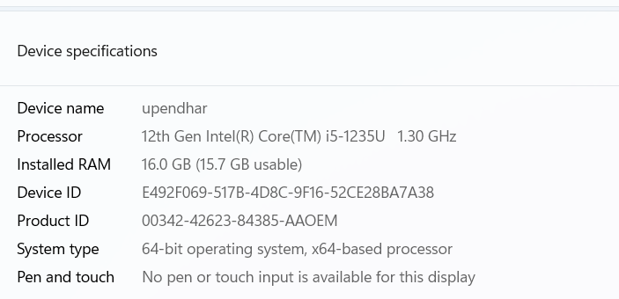
Intel: Intel ~400mz, with 96mb* of Ram for NT workstation client.
Intel ~400mz, with 64mb *of Ram for 98 workstation client.
(* Automation needs an additional 128MBs to function)

9.Schedule
Test Documentation
Document | Development Time |  | Sign-off Date | Dependencies
 | Person-Days | Completion Date
Test Plan | 1 day | Today | 20/11/24 | Functional Spec. Review
Test Specifications | 1days |  |  | Testplan, Functional Spec, Review
Test Logs | TBD
Test Summary Report | TBD
Checklist | TBD

Test Development
Deliverable | Development Time |  | Dependencies
 | Person-Days | Completion Date
Functional Test Suite | 1
Automation build

Test Execution
Test Activity |  | Execution Time (Person-Days) |  |  | Dependencies
 |  | Alpha | Beta | FCS
Acceptance |  | 1 Days | 1 Days | 1 Days
Functional | Functionality | 1 | 1
 | Usability | All High to Medium testcaces
 | Robustness | All High to Medium testcaces
 | Stress | All High to Medium testcaces
 | Multi Inst. | All High to Medium testcaces
Regression
Documentation Review |  | 1? | 1? | 1?
Total Test Cycle |  | 1 | 1 | 1

10.Issues/Risk and Contingencies
Risks:
Environment Instability: Delays in setting up the test environment could impact the schedule- VM is not working port no.-5103
Resource Availability: Limited availability of testers could delay test execution.
Late Requirement Changes: Changes in requirements during the testing phase could lead to additional testing efforts.
Contingencies:
Backup Resources: Have backup resources ready to join the testing effort if required.
Flexible Schedule: Allocate buffer time in the schedule to accommodate unexpected delays.
Regular Communication: Hold daily stand-up meetings to quickly address any issues that arise
11.Approvals

POSITION  *Approval required | NAME | SIGNATURE | REVIEWED | APPROVAL
Tech Lead | Raghu |  | Raghu | Raghu
Project Manager | Upendhar |  | Raghu | Raghu
Client Approval | Raghu |  | Raghu | Raghu

